MacKay Shield Best Bond Report – User Manual

Overview:
The Best Bond Report was developed as a subset of the Universe Report and will compare the MLBI holdings to the Portia (MacKay Shields) holdings. The Best Bond Report displays all issues held by MacKay Shields and any issues in the Merrill Lynch Bond Index from the same issuers. The issues are grouped by issuer and sorted by issuer. The following outlines the general user requirements of the Best Bond Report:
- Price change differences against any other issue from the same issuer greater than X where X is user defined.
- If the price change scenario yields an OAS of 50 or less, 50 basis points (bp) will be used. These will be highlighted and bolded in a burnt red color on the report.
- The report is sorted by Issuer and then Maturity.
- Issues held by MacKay Shields are highlighted and bolded in light blue and indicate an H in the Held column.

User Manual

General Requirements:
There are specific software requirements that are detailed below.
- The Desktop where the report is run must have user access to the Bloomberg API and DDE Server Excel Add-Ins. More information regarding software support and installation of the DDE Server Add-Ins for Bloomberg are available at the following website: http://about.bloomberg.com/software/info_api.html
- User must have MSExcel 2003 or higher.
- The Macro security in MSExcel should be turned on to Medium. To verify that it is, in MSExcel go to:
  - Tools/Options and select the Security Tab.
  - Click on the Macro Security… button.
  - Select the Medium radio button and click OK.
- When using the MSExcel Reports, do NOT change the names of the tabs within the spreadsheet. In addition do not change the name of the MSExcel file. If a user wishes to manipulate the data, open a new instance of MSExcel and copy paste the data from the existing spreadsheet to a new spreadsheet.
Step 1: Loading the Portia Holdings and HW00 Holdings
- Download the Portia Holdings report and save it to the following directory: G:\High Yield Active Core\ Credit Screening\ Holdings Data \ Holdings-Global.
- A sample file format from Portia is provided below. The same format (meaning all of the columns should be the same) should be used every time the report is run:

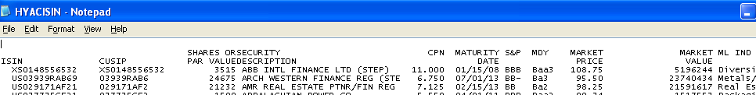

****NOTE: Be sure that the file name and extension is HYACISIN.txt

- Download the Merrill Lynch Bond Index Holdings report and save it to the directory: G:\High Yield Active Core\ Credit Screening\ ML Data \ML-Global.
- A sample file format from the Merrill Lynch Bond Index is provided below. The same format (meaning all of the columns should be the same) should be used every time the report is run:
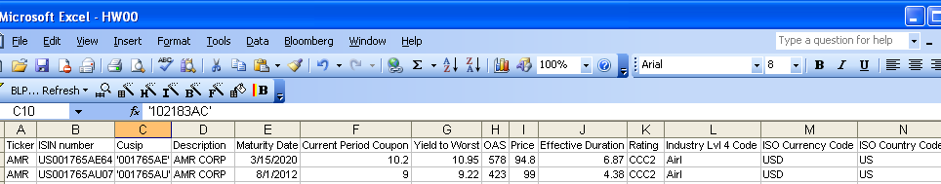

****NOTE: Be sure that the file name and extension is HW00.csv

Step 2: Running the Best Bond Report
- Open the report called BestBondReport.xls located in the G:\High Yield Active Core\ Credit Screening\ Arb Reports directory.
- Click on the Summary Tab.
- Input the 4 OAS Price Change scenarios into the Scenario 1, Scenario 2, Scenario 3 and Scenario 4 fields. OAS Price changes are in Basis Points and a “-“is required for price changes that should be subtracted.

****NOTE: The OAS threshold is set to 50bp. Therefore those issues that have a price change less than 50bp will be set to 50bp.

- When satisfied with the OAS Price Change Scenarios, click on the Run Report button.

****NOTE: Since the report is dependent on the number of holdings and the network traffic on the Bloomberg server it is recommended to run the report closer to the End of Business. In addition, this report can take up to one hour to complete and will withhold the use of MSExcel while it is running.

- Once the report has completed running the Report Tab will open. For printing the report please see printing and saving the report section.

Step 3: Printing & Saving the Best Bond Report
- Printing
  - Click on the Print tab.
  - Click on the Print button.
- Saving
  - Reports will not automatically be saved when they are run.
  - If a user wishes to save the report that was run, go to File/SaveAs.
  - Rename the file and save the file to a directory that will be easy to remember.

Data Sources and Field Information:
The following details the field names and data source for each field in the report.

Field Name | Source | Other Information
Industry | HW00
Issuer | HW00 | Primary Sort
Maturity Date | HW00 | Secondary Sort
Coupon | HW00
YTW | HW00 / Bloomberg | If data is not in HW00, taken from Bloomberg.
OAS | Bloomberg
Price | Bloomberg
Ratio | Calculated | Market Value / Accreted * 100
Accreted | Bloomberg | **If it is a 0 Coupon Step Up bond find the backend yield from Bloomberg and plug into YTM field.  **If it is a 0 Coupon for the life of the bond the original issue price and first settle date must be obtained from Bloomberg. The YTW needs to be calculated for the original date and price (via the YAS page in Bbg). The calculated YTW along with today’s date will give the accreted value.
Effective Duration | HW00 / Bloomberg | If data is not in HW00, taken from Bloomberg.
Moody Rating | Bloomberg
S&P Rating | Bloomberg
Curr | HW00 / Bloomberg | If data is not in HW00, taken from Bloomberg.
Country | HW00 / Bloomberg | If data is not in HW00, taken from Bloomberg. Not on the printed version
Next Call Date | Bloomberg
Call Price | Bloomberg
dPrice1 (OAS+/-W) | Bloomberg | User defined field (OAS – W) is loaded into Bloomberg that calculates the dPrice1
dPrice2(OAS+/-X) | Bloomberg | User defined field (OAS + X) is loaded into Bloomberg that calculates the dPrice2
dPrice3(OAS+/-Y) | Bloomberg | User defined field (OAS + Y) is loaded into Bloomberg that calculates the dPrice3
dPrice4(OAS+/-Z) | Bloomberg | User defined field (OAS + Z) is loaded into Bloomberg that calculates the dPrice4
HELD | HYACISIN | Indicates if security is held and highlights the row in blue/bolded font.
CUSIP | HW00 / HYACISIN | If not in HW00 data is taken from HYACISIN.

